How to enable Auto Calculation in QLE:

Steps are –

1. Go to setup and search for installed packages
2. Click on Pricing and Calculation tab
3. Check Calculate Immediately checkbox  
   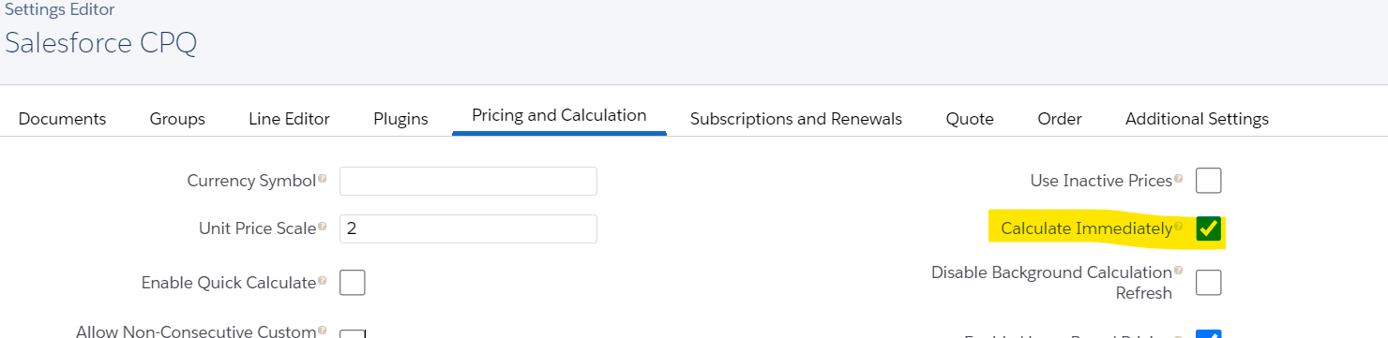

**3. Block Price:**

* The block price is tier-based pricing. Tier-based pricing means that the price of the product depends on the quantity that a customer is purchasing.
* The price is also based on the range of the quantity and not the individual product
* For Example- Let's say your company is selling printer papers. and the requirement is if the customer order paper from 1 to 100 then the close will be 25 USD for 101 to 200 the code is 50 USD and from 201 to 300 it is 75$, which is an example of Block Price.

[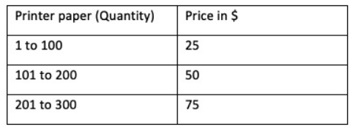](https://www.blogger.com/blog/post/edit/5479395999909322176/5600466011164237225)

**Steps to configure Block Price:**

1. Navigate to the Product tab and click on New
2. Product Name- Printer Paper, check Active checkbox
3. In the Salesforce CPQ Pricing section, you will see a field Pricing Method, Select **Block**
4. Save the changes
5. Go to related and click on new next to the Price Books section
6. Add a price of 50 USD and save the changes.
7. Click on the **Edit All** button next to Block Price
8. Fill in the values as per requirement. Click on the Plus icon to add the rows in the table

[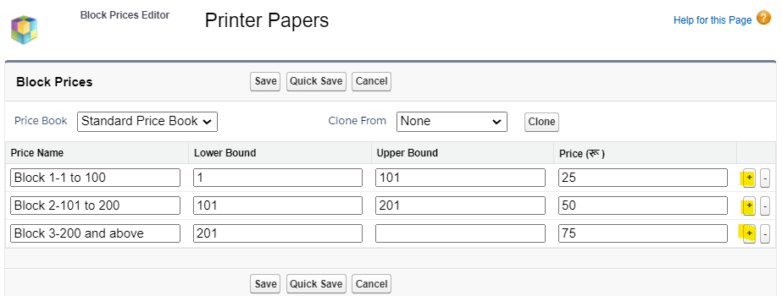](https://www.blogger.com/blog/post/edit/5479395999909322176/5600466011164237225)

1. Click on the Save button.

**FYI** - Any quantity between 1 and 100 will have a price of $25 when added to the QLE. Similarly, the price for other blocks will be applied as configured in the above image. Block price is the absolute price for the quote line and NOT the unit price that gets multiplied by quantity to arrive at the final price

**What is OverageRate in Block Price?**

* In the above example where we gave a range but what if your customer wants to buy just a few more additional units. Like in the block 3 customer wants to buy 305 units.  To handle such type of requirement CPQ gave an extra special field called **OverageRate.**
* **OverageRate (**(API name OverageRate__c) allows us to define the per-unit price for any quantity above our highest tier.

**How block price will calculate if  OverageRate is given?**

* The formula is -  applicable block + (additional units *overage rate).
* If OverageRate is 1 dollar per additional unit then for 305 units it will be 75 + 5*1 = 80USD

**How to enable the OverageRate field?**

1. Go to App Launcher and click on Object Manager
2. Select Block Price and click on Field & Relationship
3. Click on New and select Currency Click on Next
4. Field name give - OverageRate (API name OverageRate__c)
5. Next and save changes
6. Go to Product Printer Paper product and under related tab click on Edit
7. You will an additional field will show -

[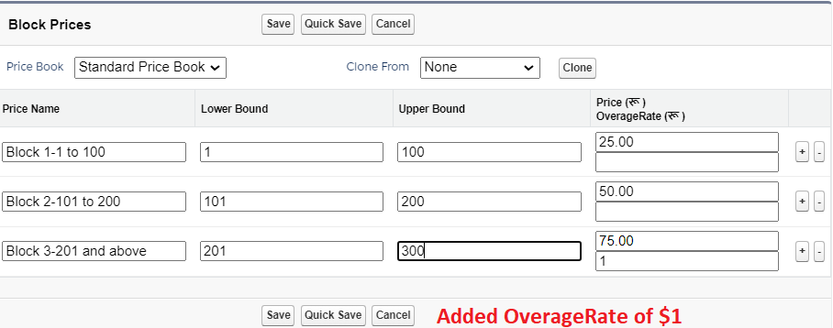](https://www.blogger.com/blog/post/edit/5479395999909322176/5600466011164237225)

**4. Percent of Total (PoT):**

* In this method, List Price is calculated as the Percentage of the total of other line items.
* Let's understand this with an example. your company is selling TV and the TV Installation is a product in Salesforce. The cost of installation depends upon the size of the TV. The installation is 5% of the total TV price.

**Steps to configure Percent of Total Price:**

1. Create a product name it -TV Installtion,
2. Put Price Method as 'Percent of Total'
3. Percent of total - 5%
4. Price of total Base to Net
5. Check Active checkbox
6. Save the record and create a Price book of 50 USD
7. Create another product. Product Name 55 Inch TV, Price Method- List
8. Save the record and create a Price book of 500 USD

[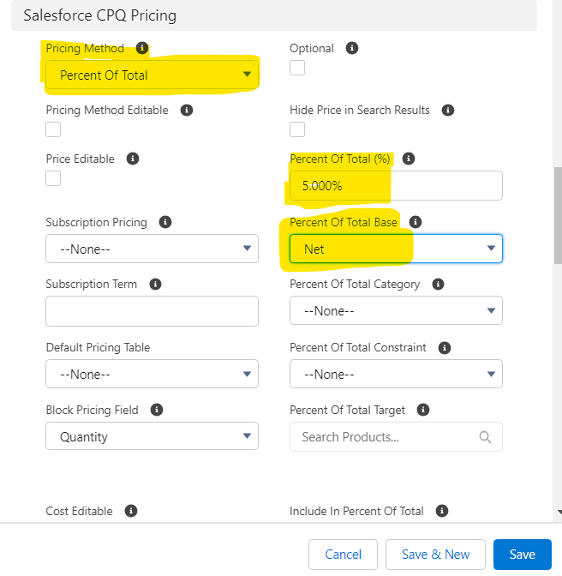](https://www.blogger.com/blog/post/edit/5479395999909322176/5600466011164237225)

1. Now go to any quote and click on Edit line
2. Add the TV installation product you will notice the Net total is 0
3. Now add another product 55 inch TV
4. The net total will auto-calculate the total and add the installation price as well.

[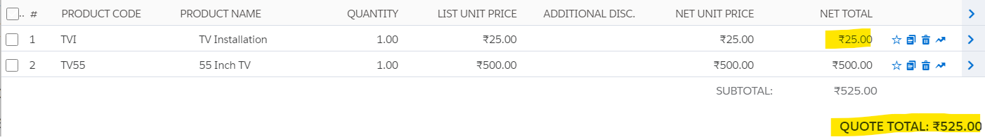](https://www.blogger.com/blog/post/edit/5479395999909322176/5600466011164237225)

Interview Questions:

1. What is block pricing in Salesforce CPQ, and when would you use it in a pricing strategy?
2. What challenges can arise when implementing block pricing in Salesforce CPQ, and how can they be mitigated?
3. Can you provide an example of a real-world use case where percent of total pricing in Salesforce CPQ would be beneficial?
4. How can you ensure that percent of total/ block /list /cost pricing rules are accurately calculated and reflected in the final quote for the customer?